Annual GOS Complaints Submission: 2024/25
National Briefing – March 2025
Dear
Following last year’s annual GOS complaints submission, we are writing to confirm the dates and process for this year’s submission.
The online data submission will be open between 9.00am Monday 28 April 2025 to 11.59pm Friday 6 June 2025. Access to the survey will require you to input your ODS code. If you are unsure of your code, you can look up your practice using NHS Digital's ODS Portal.
You can submit your complaints data online detailing any NHS complaints received within the 2024/2025 financial year.
You can also access the form by scanning the QR code below:
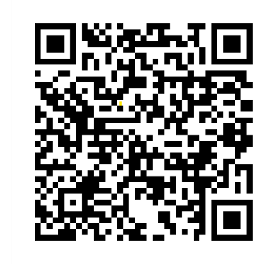
Alternatively, the submission can be accessed on the Provider Assurance Ophthalmic website.
Once you have accessed the submission, the first task you will be required to complete is to confirm the name and email address of the person completing the form. Stage two will then be to enter the number of complaints received. In the case that a practice has received no complaints please enter ‘0’ within the capture field. Prior to submitting your completed response, you will be taken to a review page in order that you may check the information entered.
Your response will be collated along with responses from fellow GOS contractors and shared with NHS England and your local ICB.
This collection remains a contractual requirement.
Should you have any queries, please contact the Provider Assurance Ophthalmic team by e-mail at: pao@nhsbsa.nhs.uk
Our core opening hours are Monday to Friday, 8.00am – 4.30pm.

