7 Zip User Guide

If necessary download and install 7-zip, a free compression and encryption application from http://www.7-zip.org/

- Browse to the file, files or directory that you wish to encrypt and select them.

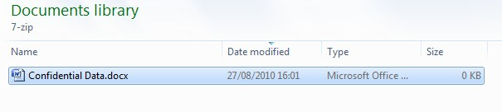

- Right click on the selected items and then select 7-zip -> Add to archive...
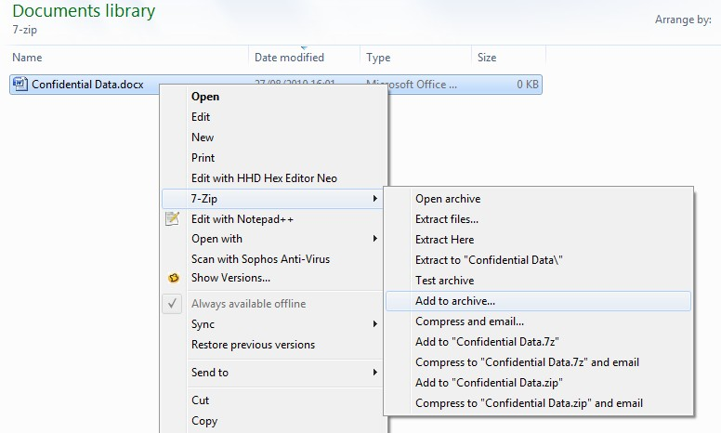
- It is recommended that the following options are selected:

    - Archive format: 7z
    - Encryption method: AES-256
    - The password must conform to 3 words or a minimum 12 character Password
    - Encrypt file names (not available for zip archives)

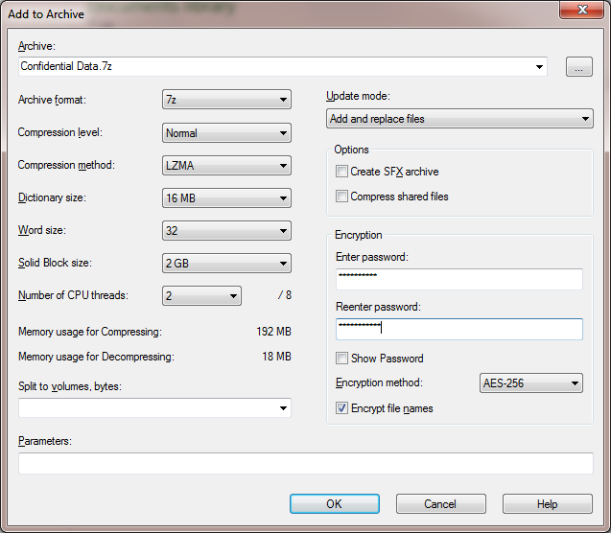

- You should then have a compressed and encrypted archive of your data.
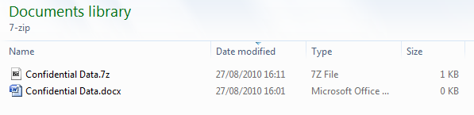

- Attach the encrypted archive to your email. This is the one with the 7z file extension.

- Remember to communicate the password to the recipient via a different method.

