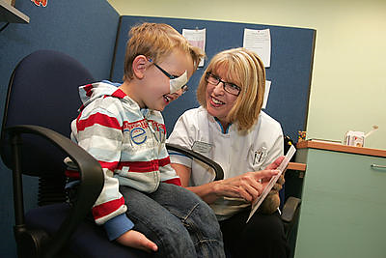
Applicant Guidance

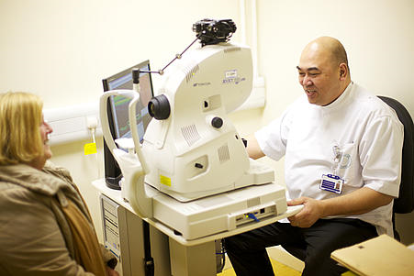

Lancashire and South Cumbria

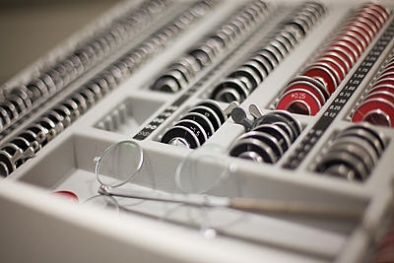

November 2018

Contents Page

Introduction 3
- Contract Application and Background Checks 4
- Contract Visit 5
- Contract Issued 6
- New Contractor Codes 7
Optometry Team Contact Details 8

Introduction
The Optometry Team has responsibility for all GOS optometry contracts in Lancashire and South Cumbria. This includes the management of Mandatory and Additional contracts.

The Applicant Guidance has been produced to help all contractors, new and existing, to apply for GOS optometry contracts whether you are purchasing a new practice as a new contractor, relocating an existing practice or applying for an Additional (domiciliary) contract.

GOS applications can take up to three months to process, from the date on which a completed application is received by NHS England’s Lancashire and South Cumbria (L&SC) Team, and including the contract assurance visit, to the date on which the GOS contract is issued. In all cases, the L&SC Team endeavors to process GOS applications in a timely manner. It is important to note that applications can occasionally take longer to process, and this is usually because an incomplete application has been received and has to be returned to the applicant for further attention. It is in all parties’ interest to accommodate preferred dates wherever possible to ensure a smooth transition and minimal patient disruption.
Part 1: Contract Application – Background Checks

- Upon initial enquiry, appropriate application forms will be sent to the applicant from the L&SC Team

- The completed forms, together with the requested supporting evidence, will be submitted to the L&SC Team

- The L&SC Team will undertake all required background checks and will contact the applicant if any further information/evidence is required

- Once the L&SC Team is satisfied that the application is complete, a mutually agreed date and time for the contract assurance visit will be arranged

Further information for the application may be requested for a variety of reasons to provide L&SC RLT with adequate assurances that the contractual information we hold is accurate and up-to-date.

Part 2: Contract Visit

- The L&SC Team will confirm the mutually agreed visit date and time by email

- The applicant will receive a copy of the contract assurance visit report template that will be used at the visit, to enable the applicant to prepare

- Any actions identified at the visit will be discussed with the applicant on the day, and will be followed up with a written visit report and action plan. Any actions identified will have a set deadline for completion

- Once the L&SC Team is satisfied that all actions have been completed, a GOS contract will be issued

Visits are arranged based on the availability of both the applicant and the L&SC RLT Optometric Adviser.

Please allow up to 2 hours for a visit.

Part 3: Contract Issued

- A draft GOS contract will be prepared and emailed to the applicant

- A copy of Schedule 2 (signature sheet) will also be attached to the email

- Once the applicant has checked the GOS contract and is in agreement with the content, they will print and sign two copies of the Schedule 2 and return by post to the L&SC Team

- The Schedule 2 will then be signed off on behalf of NHS England; and one signed copy will be returned to the applicant by post

- The applicant will be informed of the GOS contract start date (please note that the start date cannot be set until the contract assurance visit and any actions have been satisfactorily concluded)

GOS contracts are contractor and premises specific.

It is essential to note that GOS cannot be performed at the premises until the applicant has received confirmation from L&SC RLT that the GOS contract has been signed-off by NHS England.

Part 4: New Contractor Codes

- When the GOS contract has been awarded, the contractor will need to complete an Organisation Code Request Form from /digital.nhs.uk/organisation-data-service/our-services/download-forms) and send the completed form to NHS Digital at Exeter.helpdesk@nhs.net to request an ODS code (this code is needed for the Contractor Set Up form)

- The L&SC Team will email a Contractor Set Up Request Form, GOS Authorised Signatory Form, and banking details template (to be put on letter headed paper) for the contractor to complete, and the completed forms must be returned to the L&SC Team

- At this point, the L&SC Team will be able to submit the information to NHSE Finance and PCSE who will then set the contractor up on the payment system

- The contractor will receive batch headers for submission of GOS claims directly from PCSE

Please note that until an ODS code has been issued and finance codes obtained, the contractor can’t claim payment.

Optometry Team Contact Details

The Optometry Team & and Optometric Advisers can be contacted by emailing: england.lancsat-optometry@nhs.net

This is a secure email address; please ensure any confidential information is sent from a secure address.

The Optometry Team Members
Angie Ashworth – Business Manager
 01138 254775

Helen Davies – Business Support Assistant
 01138 254868

Optometric Advisers:
Ruth Cuthbert

Lancashire and South Cumbria Address:
NHS England North (Lancashire and South Cumbria)
Primary Care – Medical and Optometry Team
Floor 2| Preston Business Centre |Watling Street Road | Preston | PR2 8DY

